**Robertson Creek Chinook fecundity sampling**

**AGENDA—14 September meeting**

1. Brief round of introductions
2. Project objectives (Nick—StAD perspective, Michael for SEP?)
3. Logistics
   1. Timeframe. How much time do we have available assuming we want to sample a representative proportion of females in the run? How many days is the hatchery planning for broodstock take?
   2. Sample fish. Can the sampled females subsequently be used for broodstock? Assuming gravimetric sampling methodology (see below). Alternatively, could this be paired with sex validation of ESSR sorting?
   3. Methods
      1. Gravimetric versus absolute counts?
      2. Working space at the hatchery.
      3. Measurements to be collected from females. Scales, length, weight? pre- and post-stripping? (could be used to calculate condition), otoliths?
      4. Required equipment and materials. Knives, weighing scale(s), scale books, fish board, sample jars?, beakers?, formalin?
      5. Personnel. How many required to work at once? StAD, SEP, Hupacasath, RCH availabilities.
4. Target sample. Power analysis suggests 14 per age class should allow estimation of mean fecundities with sufficient accuracy. Ages won’t be known at time of sampling. Mean POH lengths at age are 621,706, 758 for 3, 4, and 5 year olds, respectively, with considerable overlap between ages. Solutions?
   1. Reach out for statistical advice on how to maximize probability of sampling enough females from each age class (Nick)
   2. Other points to consider: untagged jacks returning this year, missing TM on 2018 BY (3 year old females), unassociated fed fry release from 2016 (5 year old females).
5. Assign work items.

**APPENDIX**

Power analysis results indicate minimum sample of 14 females per age class for 80% power to estimate mean fecundities:

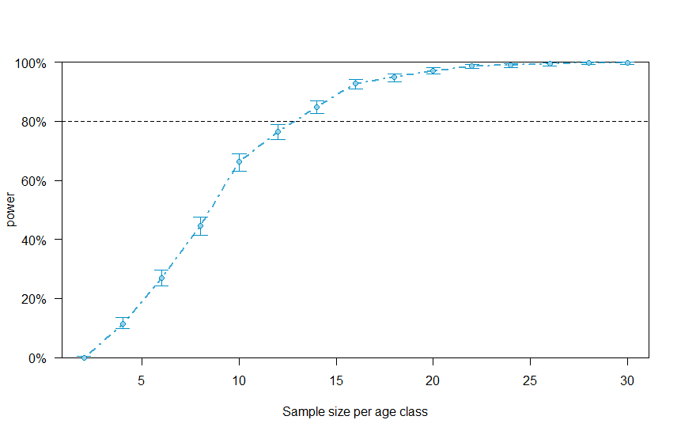

Precision curves suggest how confidence intervals will shrink with increasing sample size per age class:

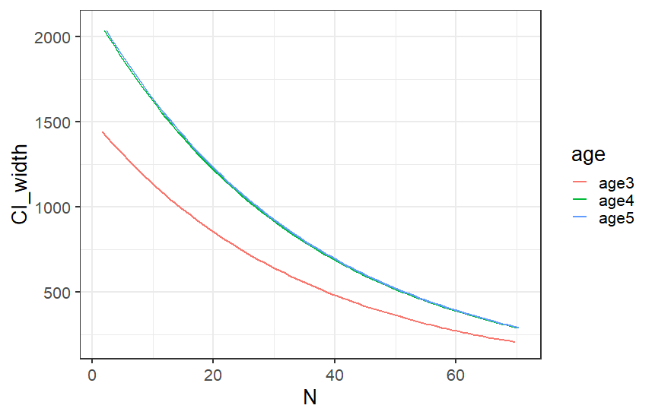

Distribution of POH lengths by age from Stamp river escapement biosamples and broodstock collections:

